***Steps in Digital Image Processing***

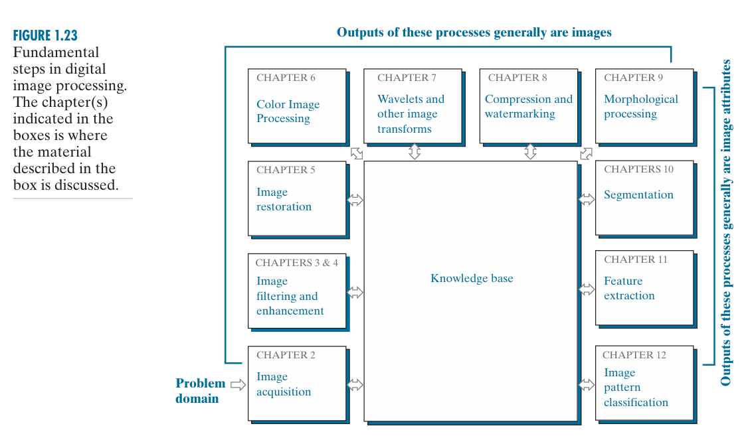

**Step 1: Image Acquisition**

* Image acquisition is the initial and foundational step in the digital image processing workflow.
* It refers to the process of capturing or obtaining an image in a digital format suitable for subsequent processing and analysis.
* The acquisition process could be as straightforward as receiving an image file that has already been digitized, or it may involve more complex steps, depending on how the image is captured.

**Step 2: Image Enhancement**

* Image enhancement is the process of manipulating an image so the result is more suitable than the original for a specific application. The word specific is important here, because it establishes at the outset that enhancement techniques are problem oriented.
* Thus, for example, a method that is quite useful for enhancing X-ray images may not be the best approach for enhancing satellite images taken in the infrared band of the electromagnetic spectrum.
* There is no general “theory” of image enhancement. When an image is processed for visual interpretation, the viewer is the ultimate judge of how well a particular method works.
* Enhancement techniques are so varied, and use so many different image processing approaches, that it is difficult to assemble a meaningful body of techniques suitable for enhancement in one chapter without extensive background development.
* For this reason, and also because beginners in the field of image processing generally find enhancement applications visually appealing, interesting, and relatively simple to understand.

**Step 3: Image Restoration**

* Image restoration is an area that also deals with improving the appearance of an image.
* However, unlike enhancement, which is subjective, image restoration is objective, in the sense that restoration techniques tend to be based on mathematical or probabilistic models of image degradation.
* Enhancement, on the other hand, is based on human subjective preferences regarding what constitutes a “good” enhancement result.

**Step 4: Color Image Processing**

* Color image processing is an area that has been gaining in importance because of the significant increase in the use of digital images over the internet.
* Color is used also as the basis for extracting features of interest in an image.

**Step 5: Wavelets and other Image Transforms**

* Image transforms such as the **Wavelet Transform**, **Fourier Transform**, **Discrete Cosine Transform (DCT)**, and **Haar Transform** are essential in image processing for tasks like compression, enhancement, and feature extraction.
* The **Wavelet Transform** stands out for its ability to decompose images into different scales, capturing both frequency and spatial information, making it ideal for multiresolution analysis.
* This localized analysis allows wavelets to handle varying image patterns effectively, unlike the Fourier Transform, which provides only global frequency data.
* The **DCT** efficiently compresses image energy into a few low-frequency components, essential for formats like JPEG, while the **Haar Transform** offers a fast, computationally simple approach for real-time applications.
* Other transforms, such as the **Radon** and **Hough Transforms**, are valuable for detecting structures like lines or shapes in images.
* Together, these transforms enable efficient image representation, analysis, and manipulation across different domains.

**Step 6: Image Compression and Watermarking**

* Compression, as the name implies, deals with techniques for reducing the storage required to save an image, or the bandwidth required to transmit it.
* Although storage technology has improved significantly over the past decade, the same cannot be said for transmission capacity.
* This is true particularly in uses of the internet, which are characterized by significant pictorial content.
* Image compression is familiar (perhaps inadvertently) to most users of computers in the form of image file extensions, such as the jpg file extension used in the JPEG (Joint Photographic Experts Group) image compression standard.
* **Image watermarking** is the process of embedding hidden information into a digital image to protect its copyright or verify its authenticity without significantly altering its appearance.

**Step 7: Morphological Processing**

* Morphological processing deals with tools for extracting image components that are useful in the representation and description of shape.
* Morphological processing is a fundamental technique in image analysis, particularly for tasks involving the extraction and manipulation of shapes and structures within an image. It is based on mathematical morphology, a framework that focuses on the geometrical structure and arrangement of objects.

**Step 8: Segmentation**

* Segmentation partitions an image into its constituent parts or objects. In general, autonomous segmentation is one of the most difficult tasks in digital image processing.
* A rugged segmentation procedure brings the process a long way toward successful solution of imaging problems that require objects to be identified individually.
* On the other hand, weak or erratic segmentation algorithms almost always guarantee eventual failure.
* In general, the more accurate the segmentation, the more likely automated object classification is to succeed.

**Step 9: Feature Extraction**

* Feature extraction almost always follows the output of a segmentation stage, which usually is raw pixel data, constituting either the boundary of a region (i.e., the set of pixels separating one image region from another) or all the points in the region itself.
* Feature extraction consists of feature detection and feature description.
* Feature detection refers to finding the features in an image, region, or boundary. Feature description assigns quantitative attributes to the detected features.
* For example, we might detect corners in a region, and describe those corners by their orientation and location; both of these descriptors are quantitative attributes.
* Feature processing methods discussed in this chapter are subdivided into three principal categories, depending on whether they are applicable to boundaries, regions, or whole images.
* Some features are applicable to more than one category.
* Feature descriptors should be as insensitive as possible to variations in parameters such as scale, translation, rotation, illumination, and viewpoint. Image pattern classification is the process that assigns a label (e.g., “vehicle”) to an object based on its feature descriptors.

**Step 10: Image Pattern Classification**

* Image pattern classification is a process in which an algorithm analyzes and categorizes visual patterns or objects in images based on their features.
* It involves extracting key characteristics like shapes, textures, edges, or color patterns, and then using machine learning models or pattern recognition techniques to classify the image into predefined categories.
* This approach is widely used in applications such as facial recognition, handwriting analysis, object detection, medical imaging, and scene classification, where distinguishing between different types of visual data is essential for accurate identification or prediction.
* Methods of image pattern classification ranging from “classical” approaches such as minimum-distance, correlation, and Bayes classifiers, to more modern approaches implemented using deep neural networks.

***Components of Image Processing System***

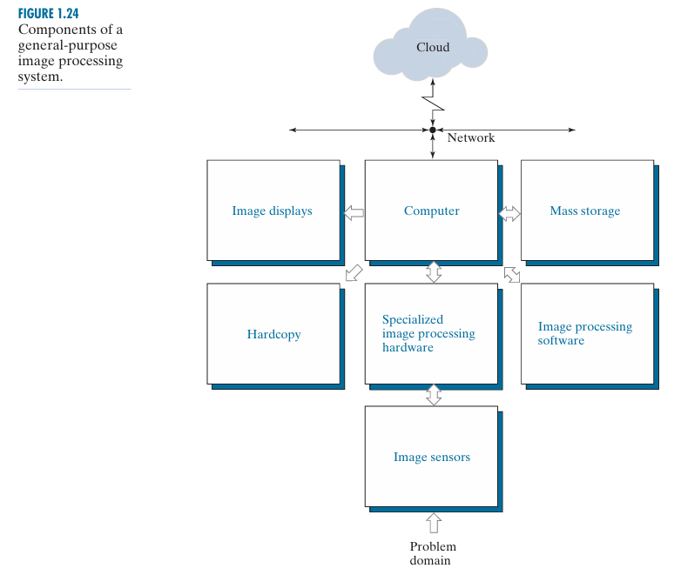

* As recently as the mid-1980s, numerous models of image processing systems being sold throughout the world were rather substantial peripheral devices that attached to equally substantial host computers.
* Late in the 1980s and early in the 1990s, the market shifted to image processing hardware in the form of single boards designed to be compatible with industry standard buses and to fit into engineering work station cabinets and personal computers.
* In the late 1990s and early 2000s, a new class of add-on boards, called graphics processing units (GPUs) were introduced for work on 3-D applications, such as games and other 3-D graphics applications.
* It was not long before GPUs found their way into image processing applications involving large-scale matrix implementations, such as training deep convolutional networks. In addition to lowering costs, the market shift from substantial peripheral devices to add-on processing boards also served as a catalyst for a significant number of new companies specializing in the development of software written specifically for image processing.
* The trend continues toward miniaturizing and blending of general-purpose small computers with specialized image processing hardware and software.

Figure 1.24 shows the basic components comprising a typical general-purpose system used for digital image processing.

**Component 1: Image Sensors**

* Two subsystems are required to acquire digital images.
* The first is a physical sensor that responds to the energy radiated by the object we wish to image.
* The second, called a digitizer, is a device for converting the output of the physical sensing device into digital form.
* For instance, in a digital video camera, the sensors (CCD chips) produce an electrical output proportional to light intensity.
* The digitizer converts these outputs to digital data.

**Component 2: Specialized Image Processing Hardware**

* Specialized image processing hardware usually consists of the digitizer just mentioned, plus hardware that performs other primitive operations, such as an arithmetic logic unit (ALU), that performs arithmetic and logical operations in parallel on entire images.
* One example of how an ALU is used is in averaging images as quickly as they are digitized, for the purpose of noise reduction.
* This type of hardware sometimes is called a front-end subsystem, and its most distinguishing characteristic is speed.
* In other words, this unit performs functions that require fast data through puts (e.g., digitizing and averaging video images at 30 frames/s) that the typical main computer cannot handle.
* One or more GPUs (see above) also are common in image processing systems that perform intensive matrix operations.

**Component 3: Computer**

* The computer in an image processing system is a general-purpose computer and can range from a PC to a supercomputer.
* In dedicated applications, sometimes custom computers are used to achieve a required level of performance, but our interest here is on general-purpose image processing systems.
* In these systems, almost any well-equipped PC-type machine is suitable for off-line image processing tasks.

**Component 4: Image Processing Software**

* Software for image processing consists of specialized modules that perform specific tasks.
* A well-designed package also includes the capability for the user to write code that, as a minimum, utilizes the specialized modules.
* More sophisticated software packages allow the integration of those modules and general-purpose software commands from at least one computer language.
* Commercially available image processing software, such as the well-known MATLAB® Image Processing Toolbox, is also common in a well-equipped image processing system.

**Component 5: Mass Storage**

* Mass storage is a must in image processing applications.
* An image of size 1024 1024 × pixels, in which the intensity of each pixel is an 8-bit quantity, requires one megabyte of storage space if the image is not compressed.
* When dealing with image databases that contain thousands, or even millions, of images, providing adequate storage in an image processing system can be a challenge.
* Digital storage for image processing applications falls into three principal categories:
  + **(1) Short-Term Storage For Use During Processing:**
    - Storage is measured in bytes (eight bits), Kbytes (103 bytes), Mbytes (106 bytes), Gbytes (109 bytes), and Tbytes (1012 bytes).
    - Another is by specialized boards, called frame buffers, that store one or more images and can be accessed rapidly, usually at video rates (e.g., at 30 complete images per second).
    - The latter method allows virtually instantaneous image zoom, as well as scroll (vertical shifts) and pan (horizontal shifts).
    - Frame buffers usually are housed in the specialized image processing hardware unit in Fig. 1.24.
  + **(2) On-Line Storage For Relatively Fast Recall:** 
    - The key factor characterizing on-line storage is frequent access to the stored data.
    - On-line storage generally takes the form of magnetic disks or optical-media storage.
  + **(3) Archival Storage, Characterized By Infrequent Access:** 
    - Finally, archival storage is characterized by massive storage requirements but infrequent need for access.
    - Magnetic tapes and optical disks housed in “jukeboxes” are the usual media for archival applications.

**Component 6: Image Displays**

* Image displays in use today are mainly color, flat screen monitors.
* Monitors are driven by the outputs of image and graphics display cards that are an integral part of the computer system.
* Seldom are there requirements for image display applications that cannot be met by display cards and GPUs available commercially as part of the computer system.
* In some cases, it is necessary to have stereo displays, and these are implemented in the form of headgear containing two small displays embedded in goggles worn by the user.

**Component 7: Hardcopy**

* Hardcopy devices for recording images include laser printers, film cameras, heat sensitive devices, ink-jet units, and digital units, such as optical and CD-ROM disks.
* Film provides the highest possible resolution, but paper is the obvious medium of choice for written material.
* For presentations, images are displayed on film transparencies or in a digital medium if image projection equipment is used.
* The latter approach is gaining acceptance as the standard for image presentations.

**Component 8: Networking and Cloud Communication**

* Networking and cloud communication are almost default functions in any computer system in use today.
* Because of the large amount of data inherent in image processing applications, the key consideration in image transmission is bandwidth.
* In dedicated networks, this typically is not a problem, but communications with remote sites via the internet are not always as efficient.
* Fortunately, transmission bandwidth is improving quickly as a result of optical fiber and other broadband technologies.
* Image data compression continues to play a major role in the transmission of large amounts of image data.